NOTE FOR BALLOT MATERIAL REVIEWERS

HL7 Domain Analysis Model: Health Quality, Release 1

Dec 17, 2014

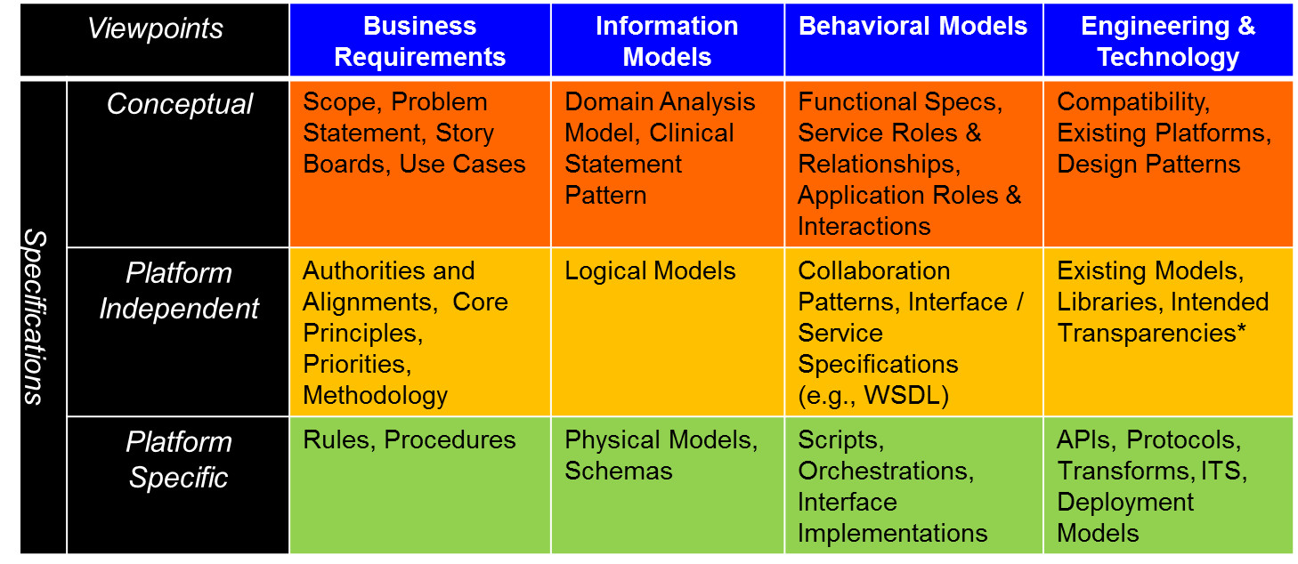This specification is part of an overall set of specifications to harmonize the HL7 standards related to quality measurement and clinical decision-support. The initial set of specifications are conceptual and include this Quality Improvement Domain Analysis Model (a conceptual information model), a specification for a metadata model (also a conceptual information model), and a specification for expression logic (a conceptual behavioral model).

QIDAM

Adapted from Keith Boone’s presentation *“An Architecture for CDS and Quality Measurement”* at the HL7 Sep 2013 WGM in Cambridge, MA.

The ballot material includes three files in addition to this document:

1. HL7_DAM_HQUAL_R1_I1_2014JAN.PDF - HL7 Domain Analysis Model: Health Quality, Release 1
2. QDM-vMR-cross-map.xlsx – A supplementary file showing the mappings among QIDAM, QDM, and VMR
3. QIDAM.eap – The domain analysis model UML diagrams in the Enterprise Architect format. A viewer for this file is available for free at http://www.sparxsystems.com/bin/EALite.exe.

The working group welcomes comments about the model. In particular, we would like feedback on the overall model architecture and directions for future development including the clinical areas to be addressed in the next version.